Welcome to Foundations of Art
Mr. Springer • Room 705
jspringer@ccs.us
Syllabus:

The coursework for foundations is new this year, so you will have a variety of projects through the course of the semester. You will complete units on the varying art subjects - photography, drawing painting, printmaking, ceramics, sculpture and graphic design. You will also be required to complete weekly sketches in your sketchbook (due dates posted below). You may also need to do outside research on given artist or artists. ** If you do not have a computer or access to a computer, please see me so we can make arrangements!!

You will receive a PREP (preparation, respect, effort, participation) grade every Day 6. You will lose points if you are late, forget your pencil, are being disruptive, etc)

Your final will be completing a online portfolio of the assignments that you have complete through out the semester. We will discuss that more during the semester.

If you are absent, it is your responsibility to find out what you missed. You will have extra time to make up your work. The time frame for completing makeup work will follow CCS’s policy that is in the Academic Handbook.

If you turn in work late you will lose 10% each day. If you are working hard you might be eligible for a work extension – You will need to see me and discuss it before the day its due!

Sign out policy: If you would like to work on your project at home or in study hall you may sign out supplies. In order to do so you need to see me before the end of class. It will be your responsibility to return the items! NOTE: Metal rulers and sharp items may not be taken out of my room for any reason!

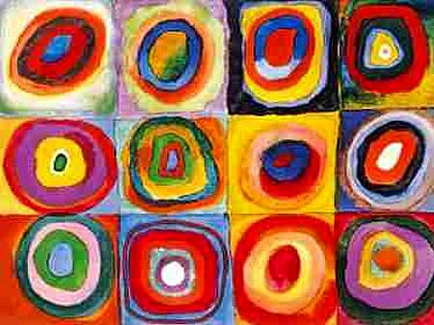

If you ever have questions see me or email me at jspringer@ccs.us

